# MAJOR ASSESSMENT

## Related to recipe.json

1) Look at the sample json data in the picture below.

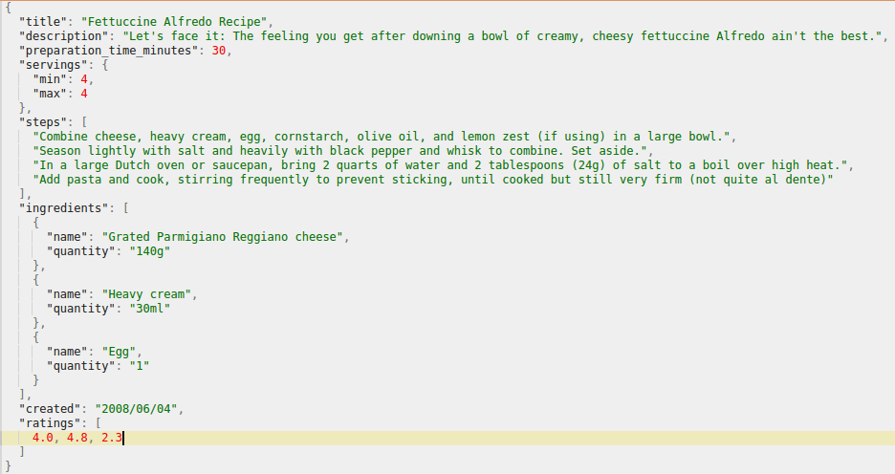

Picture I: Sample JSON Data

Create an **index with any name** that you prefer (example: recipes) along with **mapping**. When creating mapping:

* decide on what are the fields required and their respective types that should be available in the mapping of the index by looking at the sample json data in the picture above (Picture I: Sample JSON Data).

PUT recipes

{

"mappings": {

"_doc": {

"dynamic": false,

"properties": {

"title": {

"type": "text"

},

"description": {

"type": "text"

},

"preparation_time_minutes": {

"type": "integer"

},

"servings": {

"properties": {

"min": {

"type": "integer"

},

"max": {

"type": "integer"

}

}

},

"steps": {

"type": "text"

},

"ingredients": {

"type": "nested",

"properties": {

"name": {

"type": "text"

},

"quantity": {

"type": "keyword"

}

}

},

"created": {

"type": "date",

"format": "yyyy/MM/dd"

},

"ratings": {

"type": "double"

}

}

}

}

}

* create **custom analyzer** (you can provide it any name, example: new_analyzer) that can handle english stop-words and synonyms available in a file created inside the config directory of elasticsearch (example, synonyms_recipes.txt). In order to add synonyms, you can download the file in [**this link**](https://drive.google.com/file/d/1PLc4lG2hAU7kXlRhhM0Jvt0GkpCXMZJo/view?usp=sharing)**,** open it in notepad or any other text editor to see what kind of synonyms can be created and add the synonyms that you have thought of in synonyms_recipes.txt file following proper format. The custom analyzer should be provided to **description** and **steps** fields.

|  |
| --- |
| PUT analyze |
| { |
| "settings": { |
| "index": { |
| "analysis": { |
| "analyzer": { |
| "custom_analyzer": { |
| "type": "custom", |
| "tokenizer": "standard", |
| "filter": [ |
| "lowercase", |
| "custom_stopwords", |
| "synonyms_recipes" |
| ] |
| } |
| }, |
| "filter": { |
| "custom_stopwords": { |
| "type": "stop", |
| "stopwords": "_english_" |
| }, |
| "synonyms_recipes": { |
| "type": "synonym", |
| "synonyms_path": "synonyms_recipes.txt" |
| } |
| } |
| } |
| } |
| }, |
| "mappings": { |
| "_doc": { |
| "properties": { |
| "description": { |
| "type": "text", |
| "analyzer": "custom_analyzer" |
| }, |
| "steps": { |
| "type": "text", |
| "analyzer": "custom_analyzer" |
| } |
| } |
| } |
| } |

2) **Bulk insert** the data downloaded from [**this link**](https://drive.google.com/file/d/1PLc4lG2hAU7kXlRhhM0Jvt0GkpCXMZJo/view?usp=sharing) into the newly created index. The data has different recipes as documents.

curl -H "Content-Type: application/json" -XPOST "http://localhost:9200/recipes/_doc/_bulk?pretty" --data-binary @recipe.json

3) For documents having preparation_time_minutes of less than of equal to 15, the difference between min and max servings should be at least 1 and at most 3 (i.e. the difference between min and max servings should be between 1-3, inclusive). Write update by query using script to make sure that this case prevails.

4) Search for all the documents in the index. View the nested field **ingredients** of the documents. You can see that in some documents, some ingredients are missing quantity field. First, find the count of such documents. Then, update such documents in which at least one of the ingredients is missing quantity field by adding the quantity field with value ‘Per Choice’.

**Hint**: ingredients is a nested field (array of JSON objects), so you need to perform nested query along with update by query and script to do this question.

**Side Note**: First perform nested query to see how many such documents exist. After executing nested query, you can see that each document/hit that is returned has at least one JSON object that match the nested query condition in the array of JSON objects of the nested field. Only then, try performing update by query. Following this approach helps you to verify your work properly.

5) Delete unrated documents, that is, documents that have empty array in ratings field.

POST recipes/_delete_by_query

{

"query": {

"term": {

"ratings": "NULL"

}

}

}

6) Find all the recipes that use Egg as one of the ingredients. Display only title, ratings, steps, number of steps. Note that number of steps is a derived field. The documents should be ordered by average rating.

7) Execute at least 10 different aggregations for performing analysis on the data.

* You need to prepare at least 3 different metric aggregations

GET recipes/_doc/_search

{

"size":0,

"aggs":{

"total_ratings": {

"value_count": {

"field": "ratings"

}

}

}

}

GET recipes/_doc/_search

{

"size":0,

"aggs":{

"max_preparation_time":{

"max":{

"field":"preparation_time_minutes"

}

}

}

}

GET recipes/_doc/_search

{

"size":0,

"aggs":{

"stats":{

"extended_stats":{

"field":"ratings"

}

}

}

}

* You need to prepare at least 5 different bucket aggregations

GET recipes/_doc/_search

{

"size": 0,

"aggs": {

"num_of_ingredients": {

"terms": {

"field": "created",

"missing": "1969/05/05",

"min_doc_count": 0

}

}

}

}

GET recipes/_doc/_search

{

"size": 0,

"aggs": {

"created": {

"terms": {

"field": "created",

"size": 4,

"show_term_doc_count_error": true,

"order": {

"_key": "bcd"

}

}

}

}

}

GET recipes/_doc/_search

{

"size": 0,

"aggs": {

"preparation_time_range": {

"range": {

"field": "preparation_time_minutes",

"ranges": [

{

"from": 1,

"to": 20

}

]

}

}

}

}

GET recipes/_doc/_search

{

"size": 0,

"aggs": {

"preparation_time_range": {

"range": {

"field": "preparation_time_minutes",

"ranges": [

{

"key": "good",

"to": 1

},

{

"key": "better",

"from": 5,

"to": 15

},

{

"key": "best",

"from": 20

}

]

}

}

}

}

GET recipes/_doc/_search

{

"size": 0,

"aggs": {

"created_range": {

"date_range": {

"field": "created",

"format": "yyyy/mm/dd",

"ranges": [

{

"to": "2005/07/01"

},

{

"from": "2005/07/15"

}

]

}

}

}

}

* You need to prepare at least 2 different sub aggregations
  + At least 1 sub aggregation having metric aggregation within bucket aggregation

GET recipes/_doc/_search

{

"size": 0,

"aggs": {

"preparation_time_range": {

"range": {

"script": {

"source": "doc.preparation_time_minutes.value"

},

"keyed": true,

"ranges": [

{

"key": "good",

"to": 5

},

{

"key": " better",

"from": 5,

"to": 15

},

{

"key": "best",

"from": 15

}

]

},

"aggs":{

"statistics": {

"stats": {

"script": {

"source": "doc.preparation_time_minutes.value"

}

}

}

}

}

}

}

* + At least 1 sub aggregation having bucket aggregation within another bucket aggregation

GET recipes/_doc/_search

{

"size": 0,

"aggs": {

"preparation_time_minutes": {

"terms": {

"field": "preparation_time_minutes"

},

"aggs": {

"created": {

"terms": {

"field": "created"

}

}

}

}

}

}

8) Design your own search using compound bool query. The bool query should have at least 2 musts, at least 2 filters and at least 1 should. Showcase the use of synonyms, proximity (slop) and fuzziness parameters where possible in your search query.

GET recipes/_doc/_search

{

"query": {

"bool": {

"must": [

{

"fuzzy": {

"title": {

"value": "paste",

"fuzziness": 3

}

}

},

{

"match_phrase_prefix": {

"title": {

"query": "past”,

"slop": 2

}

}

}

],

"filter": [

{

"range": {

"created": {

"lte":"2012/02/20"

}

}

},

{

"term": {

"description": "pasta"

}

}

],

"should": [

{

"range": {

"ratings": {

"gte": 2

}

}

}

]

}

}

}

9) Practice using cut-off frequency to handle domain specific stop-words in match query and common-terms query. You can make use of **steps** field for this purpose.

GET recipes_search

{

"query": {

"match": {

"steps": {

"query": "Spaghetti With Spicy Tomato Sauce",

"cutoff_frequency": 0.001

}

}

}

}

GET recipes_search

{

"query": {

"match": {

"steps": {

"query": "Spaghetti With Spicy Tomato Sauce",

"cutoff_frequency": 0.005

, "operator": "and"

}

}

}

}

## Terms Lookup Mechanism and Geo Queries

10)

1. Create an index **items** with mapping having following fields:

**item_id**: integer field

**name**: text field

**stock**: integer field

**vendor**: object with properties name (text field), contact (keyword), address(geo_point)

PUT items

{

"mappings":{

"_doc":{

"dynamic":"false",

"properties":{

"item_id":{

"type":"integer"

},

"name":{

"type":"text"

},

"stock":{

"type":"integer"

},

"vendor":{

"type":"nested",

"properties":{

"name":{

"type":"text"

},

"contact":{

"type":"keyword"

},

"address":{

"type":"geo_point"

}

}

}

}

}

}

}

1. Bulk insert at least 5 documents into **items** index.

PUT items/_doc/_bulk

{"index":{"_id":1}}

{"item_id":1,"name":"Chocolate","stock": 200, "vendor": {"name": "kitkat", "contact": "014473693", "address": {"lat": 50.54, "lon": 32.55}}}

{"index":{"_id":2}}

{"item_id":2,"name":"Biscuit","stock": 100, "vendor": {"name": "Oreo", "contact": "01445566", "address": {"lat": 65.72, "lon": 42.77}}}

{"index":{"_id":3}}

{"item_id":3,"name":"Oil","stock": 400, "vendor": {"name": "Livon", "contact": "01442233", "address": {"lat": 60.55, "lon": 30.58}}}

{"index":{"_id":4}}

{"item_id":4,"name":"Lotion","stock": 150, "vendor": {"name": "Ponds", "contact": "01446677", "address": {"lat": 64.21, "lon": 42.74}}}

{"index":{"_id":5}}

{"item_id":5,"name":"Nailpolish","stock": 300, "vendor": {"name": "Sonata", "contact": "014473693", "address": {"lat": 65.32, "lon": 42.77}}}

1. Try performing geo bounding box and geo distance queries in the vendor’s address.

|  |
| --- |
|  |

GET items/_search

{

"query": {

"bool": {

"filter": {

"geo_bounding_box": {

"vendor.address": {

"top_left": {

"lat": 65.00,

"lon": 40.00

},

"bottom_right": {

"lat": 65.00,

"lon": 40.00

}

}

}

}

}

}

}

1. Create an index **category_items** with mapping having following fields:

**category:** text field

**Items:** array of item_ids, that means, array of integer

PUT category_items

{

"mappings": {

"_doc": {

"dynamic": false,

"properties": {

"category": {

"type": "text"

},

"items": {

"type": "nested",

"properties": {

"item_ids": {

"type": "integer"

}

}

}

}

}

}

}

1. Insert two documents in category_items: one related to cosmetic category and next related to household category. When inserting documents in category_items, please note that each category should have at least one item_id inserted in items index.

PUT category_items/_doc/1

{

"category": "cosmetic",

"items": [

{

"item_ids": 3

},

{

"item_ids": 4

}

]

}

PUT category_items/_doc/2

{

"category": "household",

"items": [

{

"item_ids": 2

},

{

"item_ids": 3

}

]

}

1. Using terms query with terms lookup mechanism, find the items from items index that belong to cosmetic category.

GET items/_search

{

"query": {

"terms": {

"item_id": {

"index": "category_items",

"type": "_doc",

"id": 2,

"path": "items.item_ids"

}

}

}

}

## Related to [orders-bulk.json](https://drive.google.com/file/d/1z7xKaCZF7WgCmqvyu2sX7KnsVbw6Zddi/view?usp=sharing)

*Note: I had told everybody to bulk insert orders-bulk.json into an index* ***orders*** *in class. So, I hope everybody has already created that index with mapping as instructed in class, and bulk inserted orders-bulk.json into it. If not, please do so.*

11) Create filtered alias of documents of orders index fulfilling the following conditions:

* status: processed **or** completed
* sales_channel: phone **and** app
* Having total_amount >=100

POST /_aliases

{

"actions": [

{

"add": {

"index": "orders",

"alias": "new_orders",

"filter": {

"bool": {

"must": [

{

"query_string": {

"default_field": "status",

"query": "(processed) OR (completed)"

}

},

{

"query_string": {

"default_field": "sales_channel",

"query": "(phone) AND (app)"

}

},

{

"range": {

"total_amount": {

"gte": 100

}

}

}

]

}

}

}

}

]

}

12) Perform the following queries in the filtered alias. Design your search conditions yourself.

* Term query
* Range query
* Prefix query
* Wildcard Query
* Match
* Fuzzy Match

GET orders/_search

{

"query": {

"term": {

"total_amount": 2000

}

}

}

● Range query

GET orders/_search

{

"query": {

"range": {

"total_amount": {

"gte": 100,

"lte": 200

}

}

}

}

● Prefix query

GET orders/_search

{

"query": {

"prefix": {

"salesman.name": "Alina"

}

}

}

● Wildcard Query

GET orders/_search

{

"query": {

"wildcard": {

"salesman.name": "A?lina"

}

}

}

● Match

GET orders/_search

{

"query": {

"match": {

"salesman.name": "Alina"

}

}

}

● Fuzzy Match

GET orders/_search

{

"query": {

"match": {

"salesman.name": {

"query": "Alina",

"fuzziness": 2

}

}

}

}